Materials List
Ready, Set, Grow
Parent and Leader Guidebook: pages 76-78
Lion Adventure Book: page 16 and 21

- Demonstrating basic gardening skills and understanding different types of gardens.
- Exploring where some food comes from.
- Planting a small container garden.

Materials
- Copies of Ready, Set, Grow handout, one per adult
- Copy of Den Meeting Plan, one for leader(s)
- Name tags and Sharpie
- Cub Scouts Poster Set with Scout Law, Scout Oath and Den Code of Conduct
(#621086 from Scout Shop)
- Blue tape or something to hang posters on wall

Optional
- Snack and water
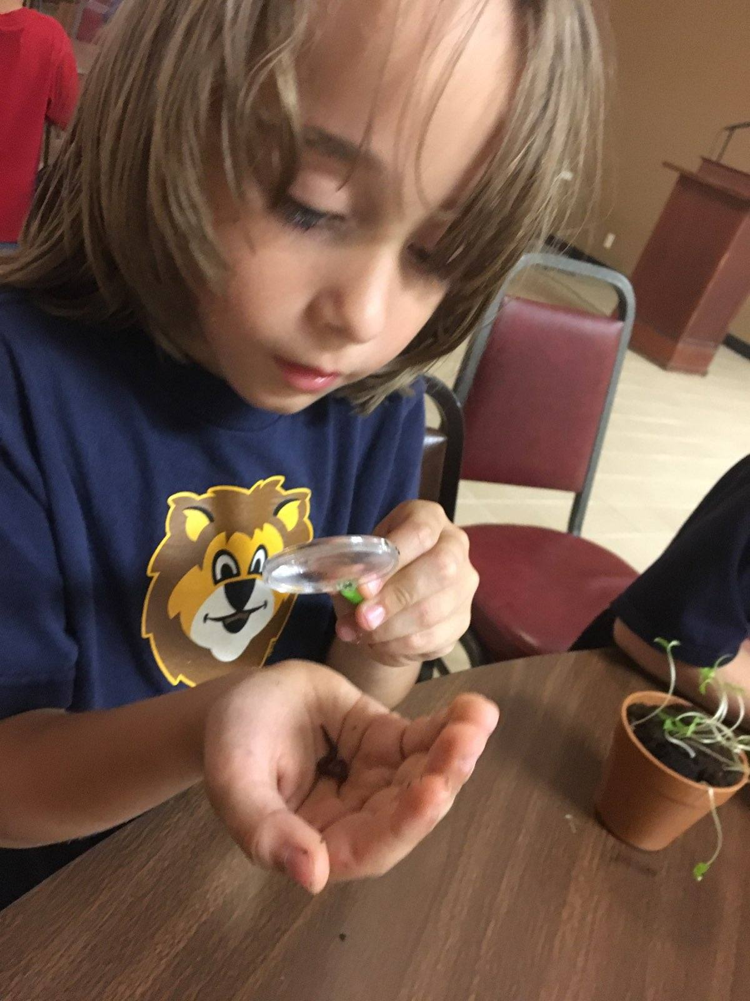
- Activities for siblings (e.g., coloring books)

Activity 1: Meet a Gardening Expert
- Find gardening expert

Activity 2: Build a Model Plan
- Recycled materials
  - shredded newspaper for roots
  - paper towel rolls, wrapping paper rolls for stem or stalk
  - newspaper for leaves
  - empty cans, masking tape, plastic food netting

Activity 3 (outing): Make a Container Garden
- Container
- Potting soil
- Seeds
- Small rocks or pebbles for drainage
- Mulch on the top, optional

Activity Wrap Up
- Glue
- Scissors
- Colored pencils, crayons or markers
- Few extra copies of Lion Adventure Book page 16 and 21 (for those who forget book).
Den Meeting Plan
Ready, Set, Grow
Parent and Leader Guidebook: pages 76-78
Lion Adventure Book: page 16 and 21

- Demonstrating basic gardening skills and understanding different types of gardens.
- Exploring where some food comes from.
- Planting a small container garden.

Gathering
- Lion, Lion, Tiger

Opening
- Good conduct candle
- Pledge, Scout Oath, Scout Law

Talk Time
- Den business
- Group discussion about where food comes from
- Sharing time

Activities
- Activity 1: Meet a Gardening Expert
- Activity 2: Build a Model Plant
- Activity 3: Make a Container Garden
- Activity Wrap-up: Lion Adventure Book, page 16 and 21

Closing
- Scout Law
- Talk about Scout Law point Thrifty

Ready, Set, Grow Adventure

Upcoming Events

Dec 16 Wreaths Across America, optional
10:00 am at Houston Cemetery

Dec 20 Pack Meeting
(bring donation of first aid supplies)

Jan 10 Den Meeting
TBD Outing

Feb 7 Den Meeting
Feb 24 Pinewood Derby
Feb 28 Pack Meeting
Mar 7 Den Meeting

Pack 72
facebook.com/pack72tomball
pack72tomball.scoutlander.com
Orion District
www.orion.shac.org
facebook.com/orionbsa
Sam Houston Area Council
www.shac.org
facebook.com/shac.bsa
Scout Law
A Scout is trustworthy, loyal, helpful, friendly, courteous, kind, obedient, cheerful, thrifty, brave, clean, reverent.
Scout Oath
On my honor, I will do my best to do my duty to God and my country and to obey the Scout Law; to help other people at all times; to keep myself physically strong, mentally awake, and morally straight.

